Know more, sell more, earn more with our new interactive training program! Available to all retail sales associates!

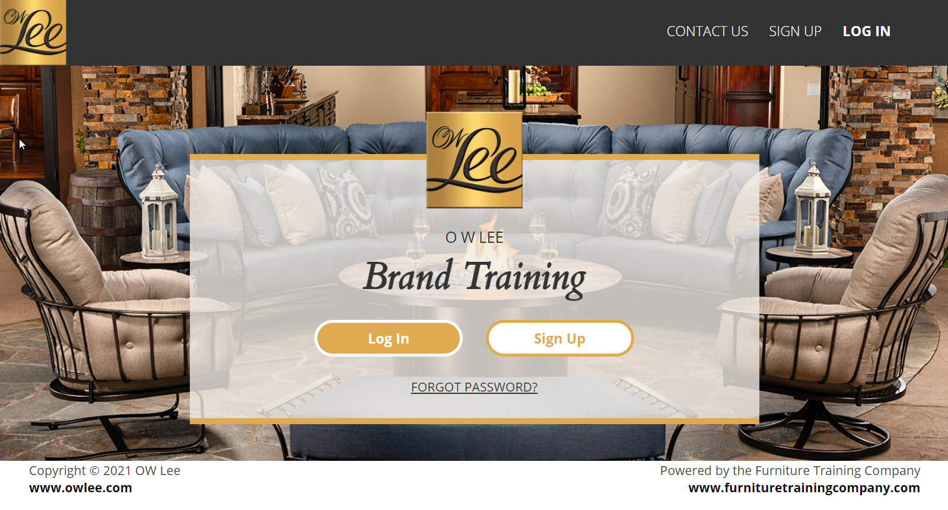

The OW Lee brand training program consists of six lessons that last about 15-20 minutes. Each lesson is interactive and includes quizzes and worksheets. Here is what each lesson covers:

Lesson 1: OW Lee Overview
Lesson 2: Materials and Manufacturing
Lesson 3: Benefits of Iron and Aluminum
Lesson 4: Casual Fireside
Lesson 5: Ordering Options
Lesson 6: Selling OW Lee Furniture

This valuable training tool is beneficial for every retail sales associate selling OW Lee. It is a crucial tool to quickly get new retail sales associates up to speed on OW Lee so they are comfortable and SUCCESSFUL at selling as soon as possible. This program is also a great refresher for more seasoned sales professionals.

There is no limit to the number of sales associates a store can sign up to use the training program!

Here is how to sign up:
1. Go to: https://owlee.brandtrainingprogram.com/
2. Click Sign Up
3. Use the access code: owleetrain
4. Fill out your first and last name and email address. Each person at the store must sign up for their own account in order to track progress.
5. Find your company name, and location (for multiple location stores)
6. Choose a username and password
7. Click register

If your store name is not available, please email leisa@owlee.com to get put into the system.

We STRONGLY encourage every retail sales associate in your store to complete the program and become a Certified OW Sales Specialist!

